**DOMINO’S PIZZA SALES QUERY**

**A. KEY POINT INDICATOR**

**1. TOTAL REVENUE:**

SELECT SUM(TOTAL_PRICE) AS TOTAL_REVENUE FROM PIZZA_SALES;

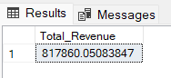

**2. AVERAGE ORDER VALUE**

SELECT (SUM(TOTAL_PRICE) / COUNT(DISTINCT ORDER_ID)) AS AVG_ORDER_VALUE FROM PIZZA_SALES

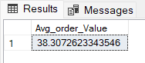

**3. TOTAL PIZZAS SOLD**

SELECT SUM(QUANTITY) AS TOTAL_PIZZA_SOLD FROM PIZZA_SALES

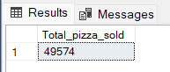

**4. TOTAL ORDERS**

SELECT COUNT(DISTINCT ORDER_ID) AS TOTAL_ORDERS FROM PIZZA_SALES

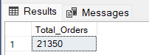

**5. AVERAGE PIZZAS PER ORDER**

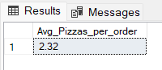

**B. DAILY TREND FOR TOTAL ORDERS**SELECT DATENAME(DW, ORDER_DATE) AS ORDER_DAY, COUNT(DISTINCT ORDER_ID) AS TOTAL_ORDERS

FROM PIZZA_SALES

GROUP BY DATENAME(DW, ORDER_DATE)

***Output:***

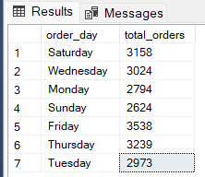

**C. HOURLY TREND FOR ORDERS**

SELECT DATEPART(HOUR, ORDER_TIME) AS ORDER_HOURS, COUNT(DISTINCT ORDER_ID) AS TOTAL_ORDERS

FROM PIZZA_SALES

GROUP BY DATEPART(HOUR, ORDER_TIME)

ORDER BY DATEPART(HOUR, ORDER_TIME)

***Output***

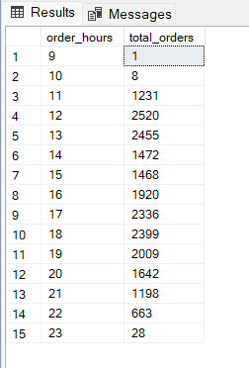

**D. % OF SALES BY PIZZA CATEGORY**

SELECT PIZZA_CATEGORY, CAST(SUM(TOTAL_PRICE) AS DECIMAL(10,2)) AS TOTAL_REVENUE,

CAST(SUM(TOTAL_PRICE) * 100 / (SELECT SUM(TOTAL_PRICE) FROM PIZZA_SALES) AS DECIMAL(10,2)) AS PCT

FROM PIZZA_SALES

GROUP BY PIZZA_CATEGORY

***Output***

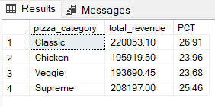

**E. % OF SALES BY PIZZA SIZE**

SELECT PIZZA_SIZE, CAST(SUM(TOTAL_PRICE) AS DECIMAL(10,2)) AS TOTAL_REVENUE,

CAST(SUM(TOTAL_PRICE) * 100 / (SELECT SUM(TOTAL_PRICE) FROM PIZZA_SALES) AS DECIMAL(10,2)) AS PCT

FROM PIZZA_SALES

GROUP BY PIZZA_SIZE

ORDER BY PIZZA_SIZE

***Output***

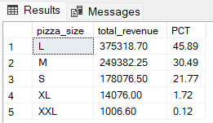

**F. TOTAL PIZZAS SOLD BY PIZZA CATEGORY**

SELECT PIZZA_CATEGORY, SUM(QUANTITY) AS TOTAL_QUANTITY_SOLD

FROM PIZZA_SALES

WHERE MONTH(ORDER_DATE) = 2

GROUP BY PIZZA_CATEGORY

ORDER BY TOTAL_QUANTITY_SOLD DESC

***Output***

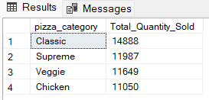

**G. TOP 5 BEST SELLERS BY TOTAL PIZZAS SOLD**

SELECT TOP 5 PIZZA_NAME, SUM(QUANTITY) AS TOTAL_PIZZA_SOLD

FROM PIZZA_SALES

GROUP BY PIZZA_NAME

ORDER BY TOTAL_PIZZA_SOLD DESC

***Output***

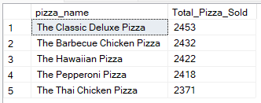

**H. BOTTOM 5 BEST SELLERS BY TOTAL PIZZAS SOLD**

SELECT TOP 5 PIZZA_NAME, SUM(QUANTITY) AS TOTAL_PIZZA_SOLD

FROM PIZZA_SALES

GROUP BY PIZZA_NAME

ORDER BY TOTAL_PIZZA_SOLD ASC

***Output***

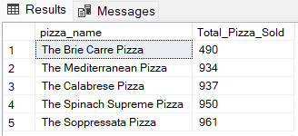

***NOTE***

If you want to apply the Month, Quarter, Week filters to the above queries you can use WHERE clause. Follow some of below examples

SELECT DATENAME(DW, ORDER_DATE) AS ORDER_DAY, COUNT(DISTINCT ORDER_ID) AS TOTAL_ORDERS

FROM PIZZA_SALES

WHERE MONTH(ORDER_DATE) = 1

GROUP BY DATENAME(DW, ORDER_DATE)

*\*HERE MONTH(ORDER_DATE) = 1 INDICATES THAT THE OUTPUT IS FOR THE MONTH OF JANUARY. MONTH(ORDER_DATE) = 4 INDICATES OUTPUT FOR MONTH OF APRIL.*

SELECT DATENAME(DW, ORDER_DATE) AS ORDER_DAY, COUNT(DISTINCT ORDER_ID) AS TOTAL_ORDERS

FROM PIZZA_SALES

WHERE DATEPART(QUARTER, ORDER_DATE) = 1

GROUP BY DATENAME(DW, ORDER_DATE)

*\*HERE DATEPART(QUARTER, ORDER_DATE) = 1 INDICATES THAT THE OUTPUT IS FOR THE QUARTER 1. MONTH(ORDER_DATE) = 3 INDICATES OUTPUT FOR QUARTER 3.*